EXERCISE Soln

1. What is data?

Data is all of the collected observations we have about something.

2. Why do we use visualizations with data?

Charts and graphs help us see patterns in data that can't be seen in a table.

3. What is the difference between a population and a sample?

A population describes all of the members of a group, while a sample is a subset of members.

A population is every member of a group we want to study.

A sample is a smaller, randomly selected set of members of the population.

4. Why do we use sampling?

Time and resources prevent us from measuring every member of a population.

5. What level of measurement describes an employee's education level?

Ordinal (education levels can be sorted but lack a formal scale).

6. What level of measurement describes the time needed to complete a project?

Ratio (values have scale and a true zero point).

7. Find the mean value of the series {6,12,8,5,10}

(6+12+8+5+10)/5=8.2

8. Find the median value of the series {7,3,11,6,9,9}

1.𝑆𝑜𝑟𝑡 𝑡ℎ𝑒 𝑠𝑒𝑟𝑖𝑒𝑠: {3,6,7,9,9,11}

2.𝐹𝑖𝑛𝑑 𝑡ℎ𝑒 𝑚𝑖𝑑𝑑𝑙𝑒 𝑣𝑎𝑙𝑢𝑒(𝑠):[7,9]

3.𝐼𝑓 𝑛𝑒𝑐𝑒𝑠𝑠𝑎𝑟𝑦,𝑡𝑎𝑘𝑒 𝑡ℎ𝑒 𝑚𝑒𝑎𝑛 𝑜𝑓 𝑡ℎ𝑒 𝑡𝑤𝑜 𝑚𝑖𝑑𝑑𝑙𝑒 𝑣𝑎𝑙𝑢𝑒𝑠: (7+9)/2

=16/2 =8

9. Find the standard deviation **𝜎** of the series {2,10,8,6,3,7}

1.𝐹𝑖𝑛𝑑 𝑡ℎ𝑒 𝑚𝑒𝑎𝑛: 𝑥̅ =(2+10+8+6+3+7)/6 =36/6 =6

2.𝐴𝑝𝑝𝑙𝑦 𝑡ℎ𝑒 𝑓𝑜𝑟𝑚𝑢𝑙𝑎 𝑓𝑜𝑟 𝑝𝑜𝑝𝑢𝑙𝑎𝑡𝑖𝑜𝑛 𝑠𝑡𝑎𝑛𝑑𝑎𝑟𝑑 𝑑𝑒𝑣𝑖𝑎𝑡𝑖𝑜𝑛:

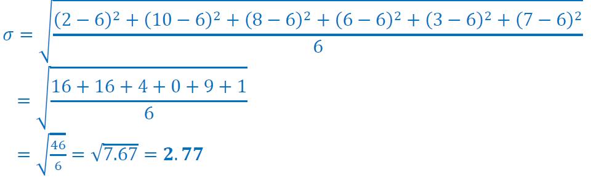

10. Divide the following series into quartiles. {5,1,6,4,2,6,7,3,1,8,4,8} What are the boundaries of the IQR?

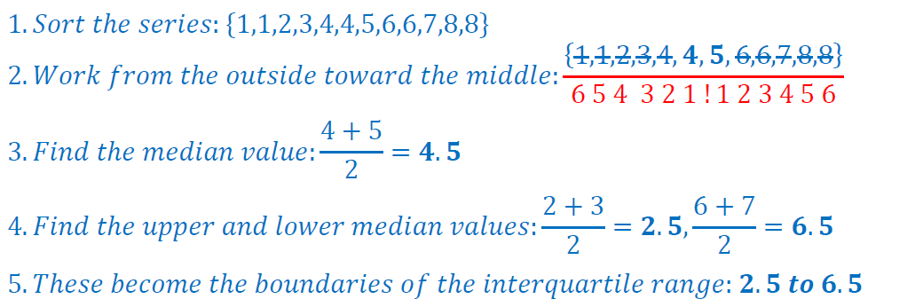

11. In the above problem, where would the upper fence fall using the 1.5 IQR method?

